# 1. Introduction

Urbanization is a complex socio-economic process associated with geographical and cultural conditions. Urban land carries more than half of the world population and consumes the most significant amount of food, water, and energy, and exports a similar level of wastes like carbon dioxide, polluted water, and heat. Knowing the land to be occupied by urban provides the opportunity for efficient resource management and waste neutralizing, thus prompt sustainable urban development.

Cellular Automata (CA) have been widely applied for urban land projections. The existence of a cell in a CA model depends on its surrounding cells (neighborhood), which could be used to represent the urban dynamics in the real world. CA models are built on transition rules that composed of driving factors (e.g., topology, transportation, population, etc.) and neighborhood status, and produce a transition potential map where each pixel indicating its probability to be urban in the future. For example, in two 9*9 cell grids, the transition potential of the central cell with five urban cells will be, according to the transition rules, greater than the one with three urban cells. Similarly, the one close to the road will have a higher transition potential than the farther one with other conditions hold the same. However, different neighborhood statuses and the complex combination of driving factors make it hard to retrieve the optimum transition rules.

Two approaches were devoted to increasing the reliability of transition rules. The first one is to introduce Machine Learning (ML) methods to CA models. This approach unravels the complex relationship between driving factors and transition potentials. [some examples from papers] However, the spatial patterns of the neighborhood cells were overlooked. For example, three cells in a 9*9 grid can be connected as a line or scattered away from each other, and these two kinds of spatial configurations often produce different transition potential to the central cell. But this difference was not well captured in ML methods (such as …). The other way, often called as participatory approach, to retrieve transition rules is to guide CA models using human knowledge. This method was built on the assumption that human deduce more reliable urban expansion rules from the real world than machine does in a finite neighborhood scope. [some examples from papers] However, it is a challenge to transform human perceptions into mathematical functions that regulate the CA models. For example, a prominent knowledge from human to urban expansion is that the transition potential decreased as the distance to transportation increased. But the rate of such decreasing is hard to determine because it often correlated with other parameters such as neighborhood size and decreasing rate of topological factor. The participatory CA models were easily overshadowed by subjectivity because it is infeasible to exhaust all possible parameters originated from human knowledge.

UNET is a deep convolutional network that is commonly used for image segmentation (ref). Down-sampling, up-sampling, and skip-connections are the primary components for UNET (ref). The down-sampling enables UNET to extract the general context of the input image, the up-sampling refined the context pattern to precise shapes, and the skip-connections balance the generalization of down-sampling and the localization of up-sampling (ref). The output of the UNET is an image of the same size as the input data, where each pixel indicating the probability belonging to a preset category.

The advancement of Deep Learning (DL) technology enables new designs to simulate urban development. The Convolutional Neuron Network is a typical DL model to extract features and has been used in simulating the land use changes. [some examples from papers] However, these studies only ingesting low-level spatial features (e.g. vertical and horizontal linear shapes) and are still bounded to the design of integrating neighborhood information to the centre cell. The DL models are capable of learning shape and pattern features from parcel images via a training process, which is fundamentally different from the CA design of providing the centre cell with neighborhood information. We hypothesis that these high-level spatial features could be directly used in simulating the urban development and achieve robust projection results.

# 2. Data and Method

The research workflow is summarized in Fig. The Landsat archive was used to mapping the urban development from 1990 to 2019 with a 3-year interval (paper-1). Digital Elevation Model (DEM) and slope were used to improve the projection performance. All raster data had the same 30m resolution and were concatenated together to increase efficiency. The training samples were randomly cropped from the training image (i.e., concatenated image that has an urban map of early date) at the size of 256 × 256 (i.e., the width and heights were 256 pixels). The UNET was trained on these samples and then applied to the base image (i.e., concatenated image that has an urban map of late date) to produce the transition potential map (i.e., image where each pixel indicating the probability to be urban lands in the future). Lastly, a threshold was determined to binarize the transition potential map into a projection map that the pixels with the value 1 were allocated as the projected urban land and 0 the non-urban land.

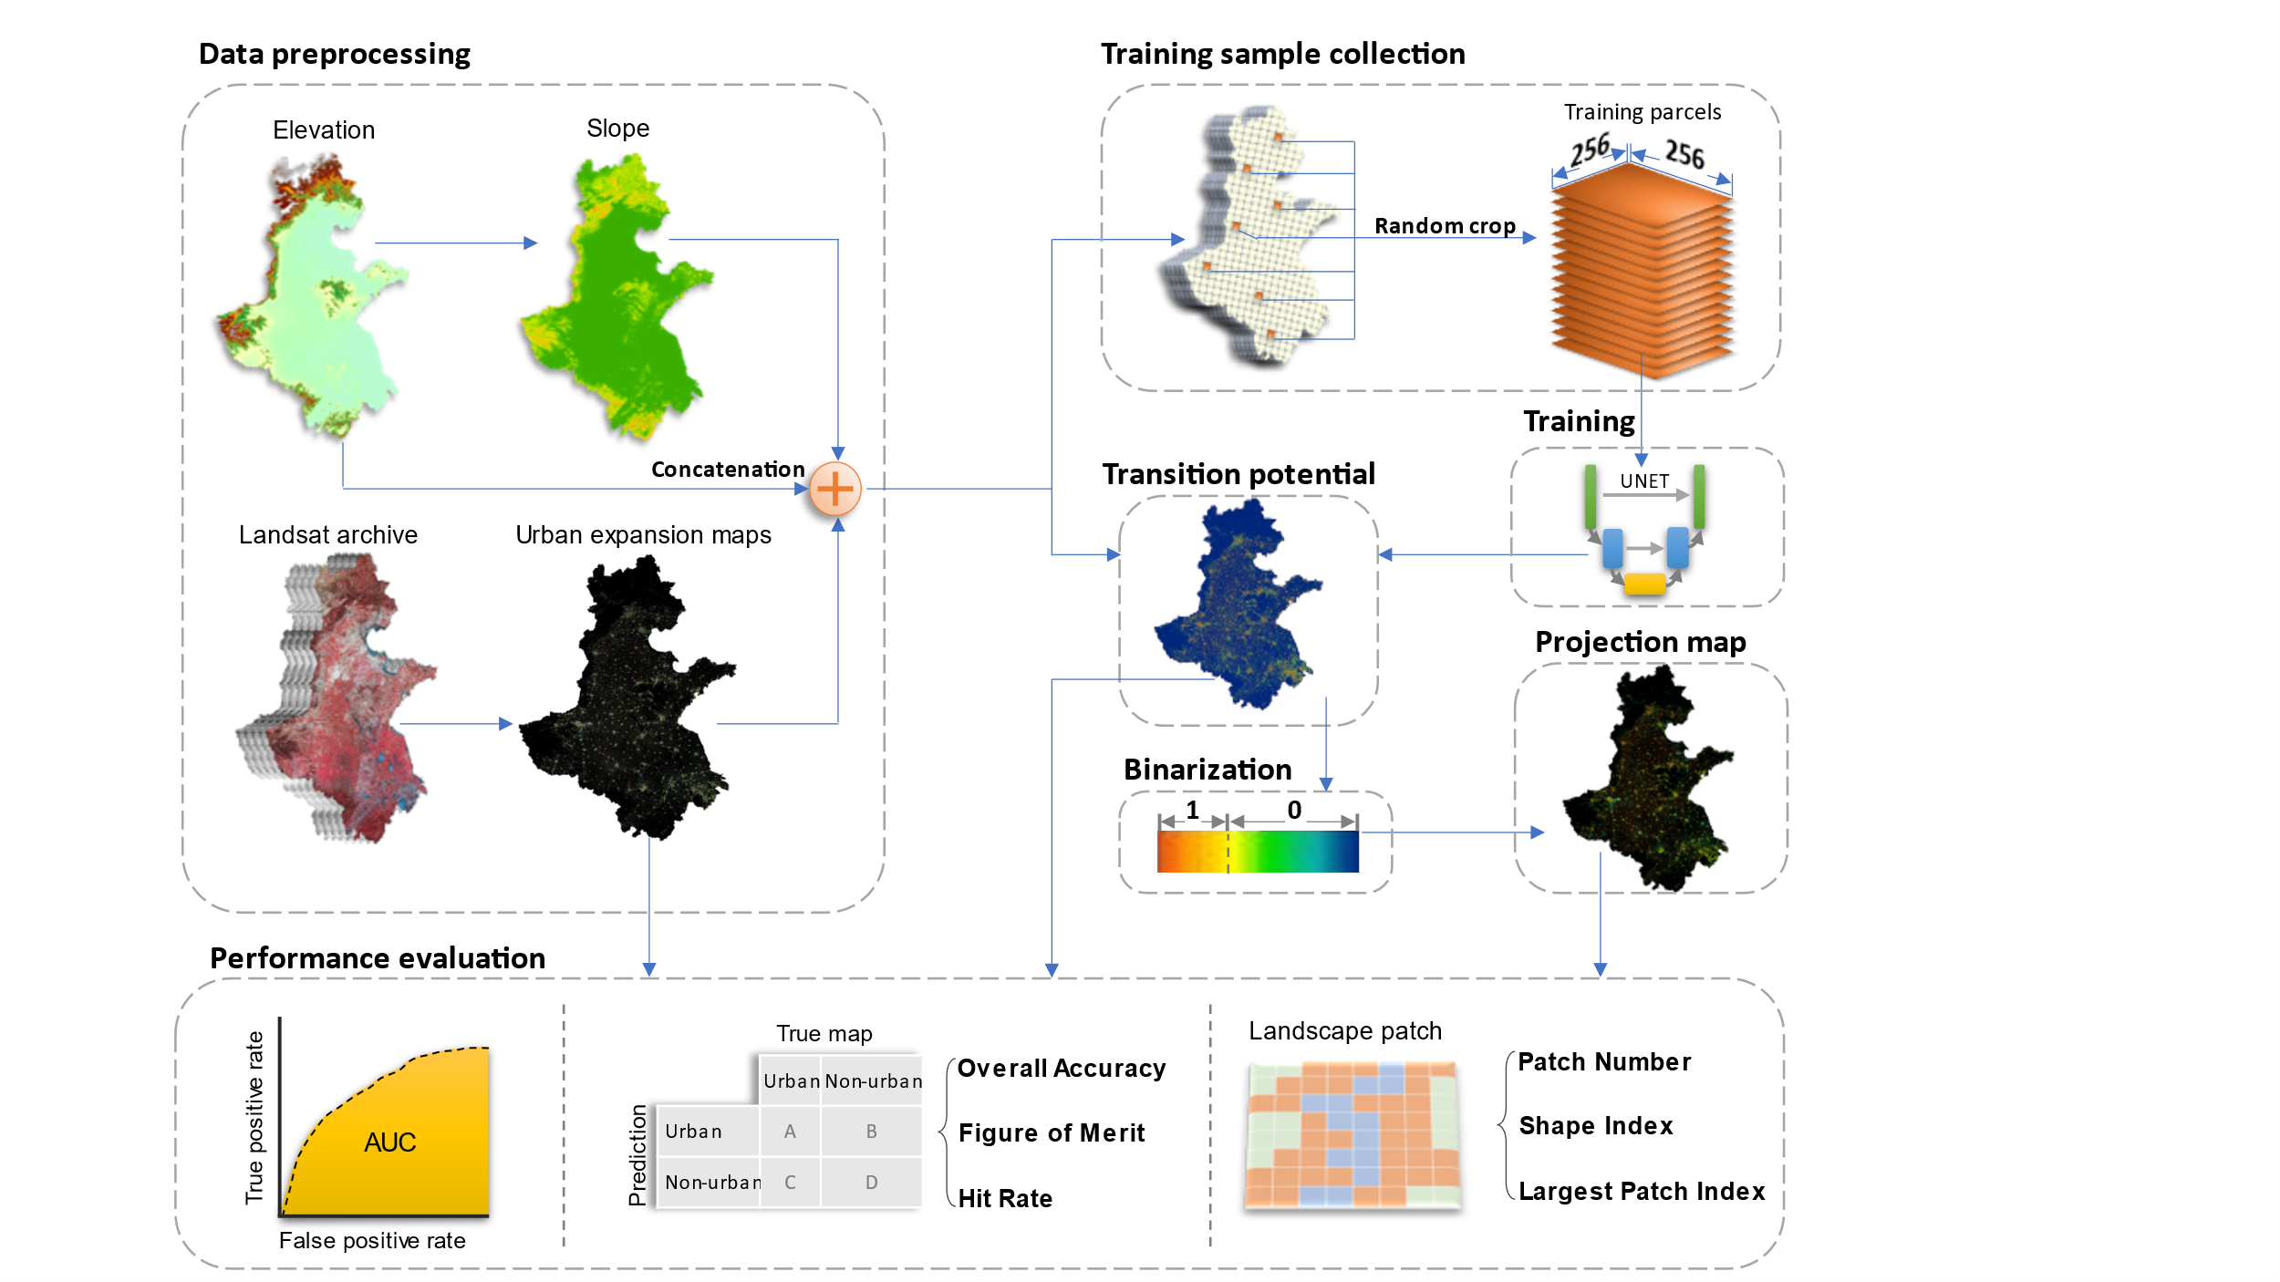

## 2.1 Study area



The study area (figure) includes 76 cities, spans over 780,000 km2 area and homes to over >450 million people (ref). This area is one of the fastest urbanized regions in China that have tripled the built-up land coverage rate from ~5% in 1990 to ~15% in 2020 (ref). This region is crucial to China’s economic development and holds a strategical role to safeguard China’s food security because over one third of national gross domestic product and grain supply was generated there(ref). The tension between urbanization and farmland conservation in the study area requires accurate and spatial-explicit understandings of the future urban development to address the challenges of food security, environmental protection, and urbanization in their infancy stage.

## 2.2 Data preprocessing

The raster data used in this study were summarized in table. The urban dynamics maps were obtained from (paper-1,figure). This product spanned from 1990 to 2019 with three-year intervals and had a consistently high accuracy of > 94% across years because the use of temporal features successfully delineates urban land from fallow cropland and a further consistent check removed unreasonable urban developments (ref). The DEM was obtained from the Shuttle Radar Topography Mission (SRTM) and the slope data was derived from the DEM. The DEM and slope were used to assist the UNET to learn urban development patterns in complicated topology conditions, which have been proven effective in previous studies (ref).

|  |  |  |  |
| --- | --- | --- | --- |
| **Data Type** | **Source** | **Resolution** | **Time** |
| Urban dynamics | Wang et. al. | 30m | 1990-2019 |
| DEM | SRTM | 30m | 2000 |
| Slope | Derived from DEM | 30m | 2000 |

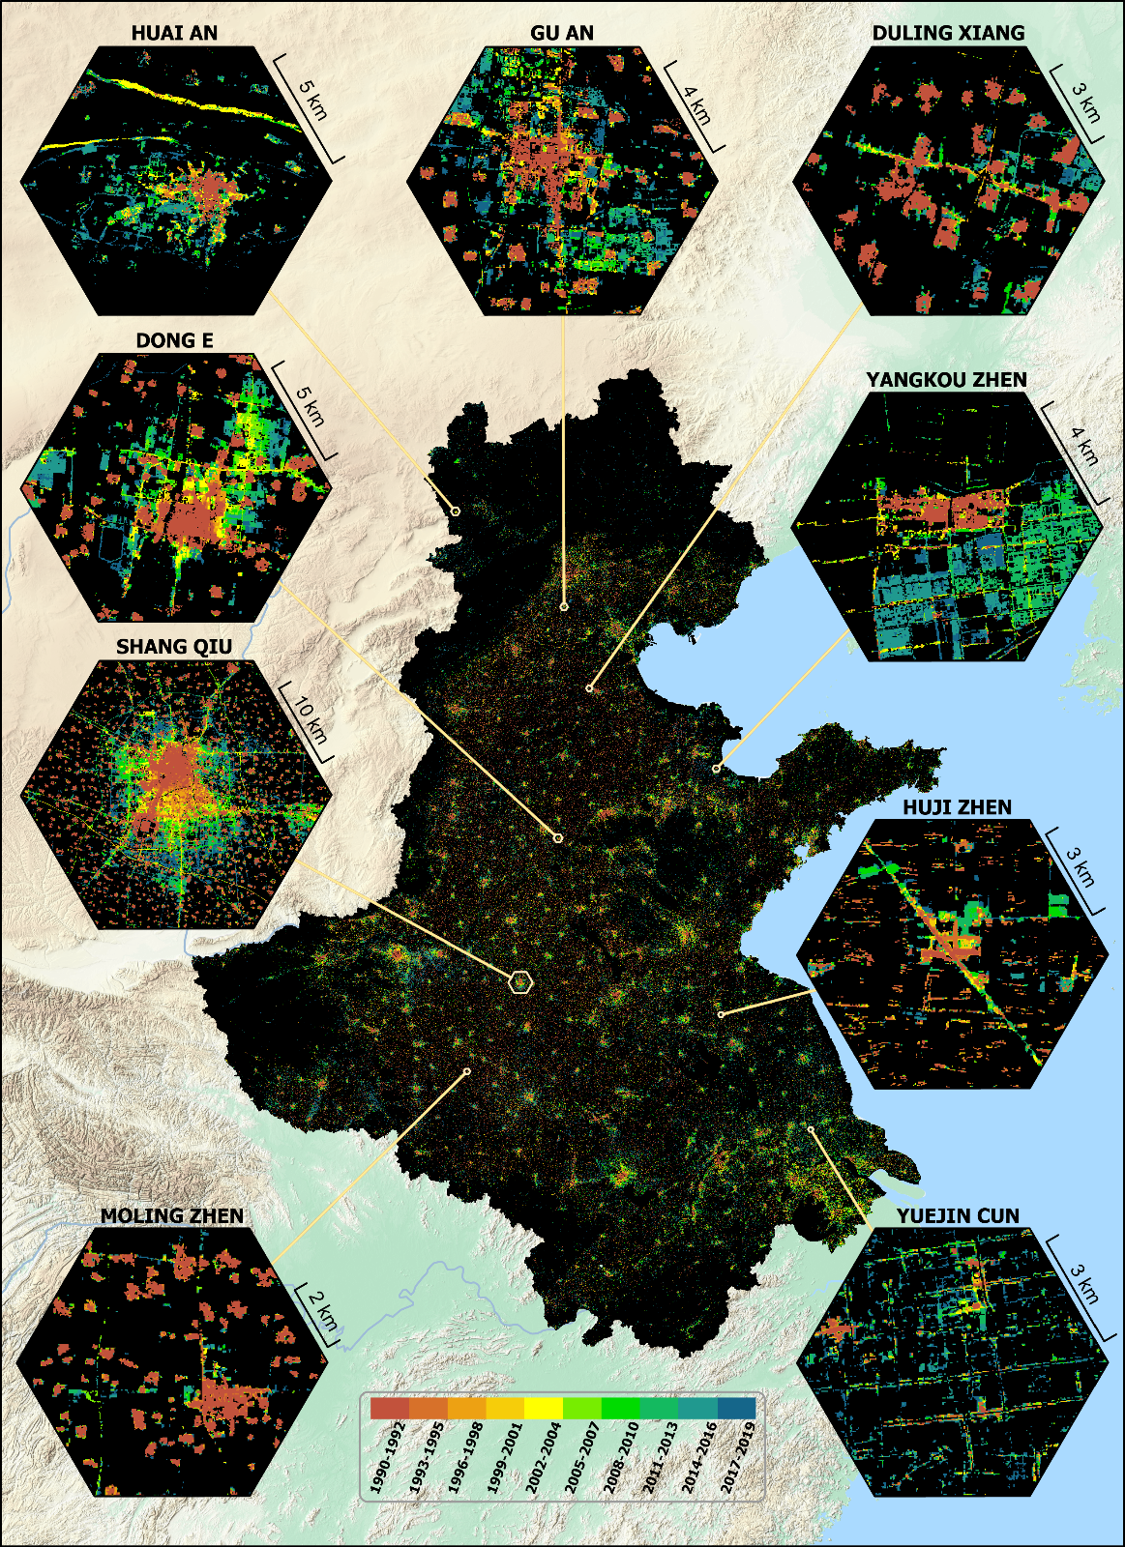

## 2.3 Control sample collection

Control samples were collected at the Google Earth Engine platform for its powerful cloud computation advantages (ref). The *neighborhoodToArray* module was used to randomly crop tiled image samples from the training image. We set the neighborhood size to 256 following common data science practices (ref) and collected 25,000 samples, of which 20,000 were used for the model training and the rest 5,000 for validation.

## 2.4 Training the UNET

The UNET was trained on tiled images with the size of 256 × 256 pixels (fig). Each training image tile includes a 3-layer input data (an urban map of 1993-1995, a DEM, and a slope map) and a single-layer target data (an urban map of 205-2007). The 3-layer input data, during training, will be transformed to the size of 8 × 8 pixels after 5 down-sampling (i.e., max pooling with kernel size and stride of two) processes, and then converted to a single-layer output image that was the same size of 256 × 256 pixels to the input image tile with another 5 up-sampling (i.e., transpose convolution with kernel size and stride to be two) operations. The mean squared error (MSE) was used to measure the difference between the output and the target image. A total of > 31 million parameters were involved in the training process and the derivative of each parameter to the MSE was computed via a backpropagation process. The parameters were updated according to the corresponding derivatives by using the Adam algorithm with a learning rate of 0.001, beta-1 of 0.9 and beta-2 of 0.99. We iterated this training process for 200 epochs (an epoch refers to the UNET have updated its parameters using all 20,000 training samples), and computed the MSE computed form the validation samples to find the best model parameters.



## 2.5 Producing the transition potential map

The base image was splited into image tiles, then supplied to the trained UNET to produce separate outputs, and then the outputs were mosaiced into a single transition potential map. The pixel values of this map ranged from 0 to 1 indicating the probability to be an urban pixel in the projection date. To reduce the “edge effect”, the image tiles were croped at the size of 320 × 320 pixels, which were 32 pixels wider than the training image tiles, and these additional pixels were used as buffer to be removed before the image tiles been mosaiced. Note although the UNET was trained on image parcels of 256 × 256 pixels, it can be applied to the buffered image parcels of 320 × 320 pixels (ref).



## 2.6 Producing the projection map

The projection map was created by binarizing the transition potential map. We computed the pixel count of the transition potential map at an interval of 0.0001, accumulated these pixel counts from the highest value to the lowest, then selected the accumulated value that was the closest to the urban pixel count in the projection year, and used it as the threshold to binarize the transition potential map.

We first validate the UNET model with historical urban maps and then produced an urban map in 2030. The validation took the urban maps of 1993-1995 and 2005-2007 for training, and the uban map of 2017-2019 to assess the trained model. Similarly, we trained another UNET model using urban maps of 2005-2007 and 2017-2019 to project an urban map in 2030. The urban area of 2030 was determined by fitting the historical urban areas with an exponential model.

## 2.7 Validate the projection

The transition potential map was assessed using the area under the curve (AUC) of the receiver operating characteristic (ROC). The projection map was evaluated via map-overlay metrics and landscape metrics(ref). The map-overlay metrics selected in this study were overall accuracy (OA), the hit rate (HR), and the figure of merit (FoM). The Lanscapte metrics of patchs (PN), landscape shape index (LSI) and larget patch index (LPI) were used in this study. The equations and explanation for selected metrics were in table.

|  |  |  |
| --- | --- | --- |
| Name | Equation | Explaination |
| AUC | $$\int_{x=0}^{1}{TPR({FPR}^{-1}(x))dx}$$ | A measure of aggregated classifications that reflects the a model’s sensitivety under different threshold (ref). |
| OA | (A + D) / (A + B + C +D) | Measure a model’s overall performance on both positive and negative aspect (ref). |
| HR | A / (A + C) | Measure a model’s predictive performance on the true positive outputs. |
| FoM | A / (A + B + C) | Measure a model’s performance on the true positive outputs from both the prediction and actual perspective. |
| PN | *n* | Reflect the fragmentation of a given landscape. |
| LSI | $$\frac{\sum{p_{i}}}{4\sqrt{\sum{a_{i}}}}$$ | Reflect the complexity of a given landscape. For example, a squared path is deemed as simple (low value) whereas a linear path is complex (high value). |
| LPI | $$\frac{max⁡(a_{i})}{\sum{a_{i}}}$$ | Reflect the dominance of the largest patch to the total landscape area. |

Note, TPR is the true positive rate, FPR is the false positive rate of the ROC of the transition potential map. A refers to correctly predicted urban pixels (hit), the B refers to the incorrectly predicted urban pixels (false alarm) , C is the incorrectly predicted non-urban pixels (miss), and D is the correctly predicted non-urban pixels (correct rejection). $p_{i}$ is the parameter (m) of the *i*th path of the urban pathes, $a_{i}$ is the area (hecter) of the *i*th path of the urban patches.

# 3. Result

## 3.2 Data processing and model training

The MSE of the validation image tiles was shown in fig, and the outputs of each layer in the selected UNET model was shown in fig.

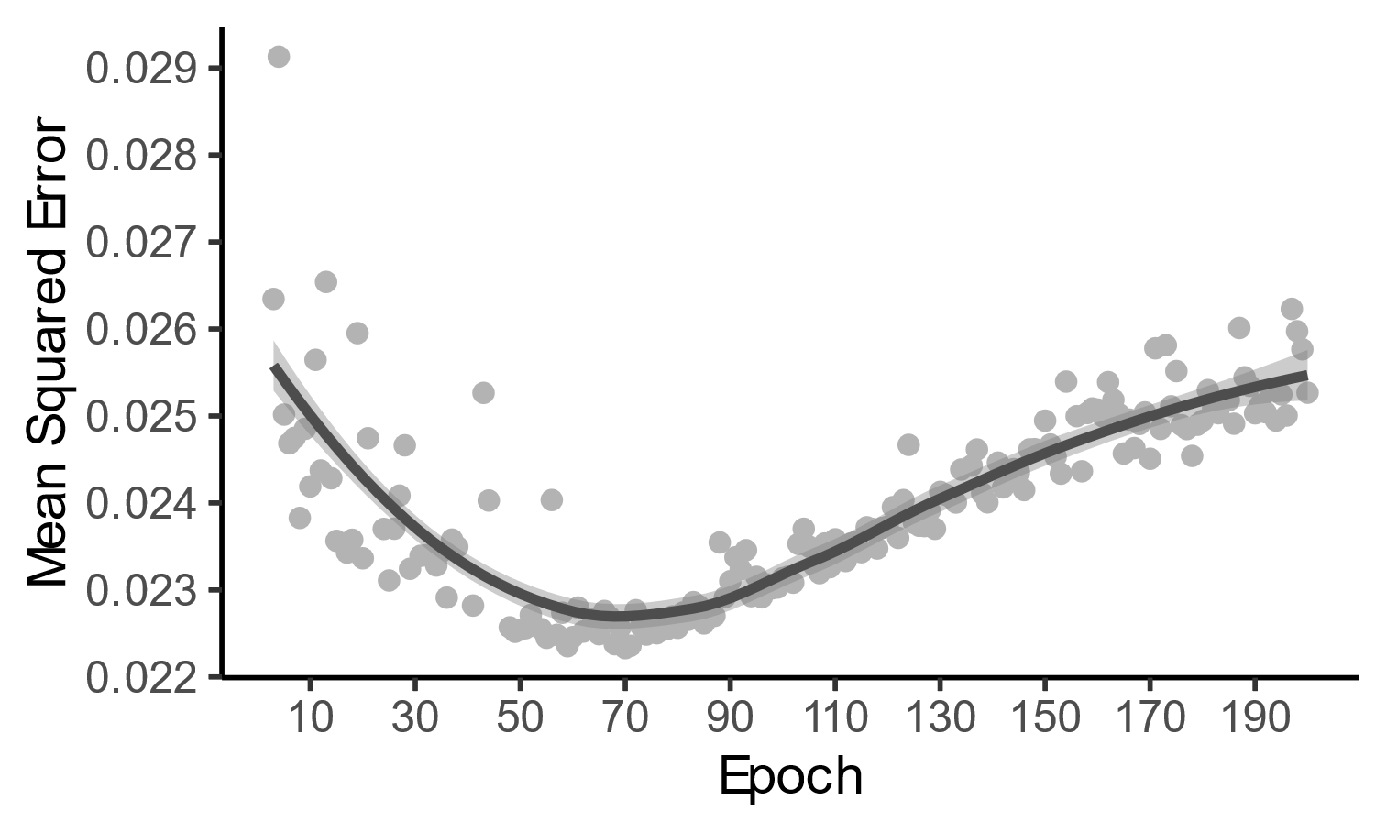

**Down-1**

**Up-1**



DEM

Slope



Urban extent

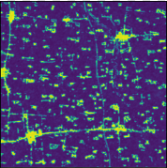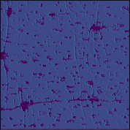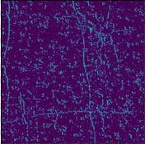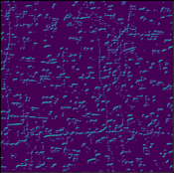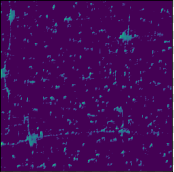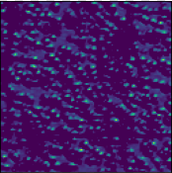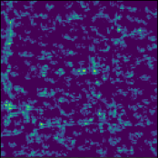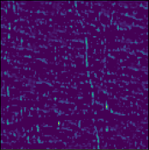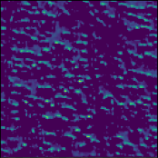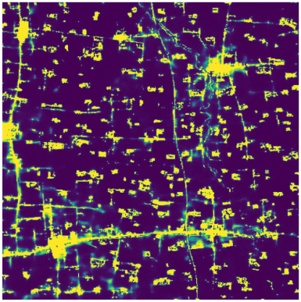

**Down-2**

**Down-3**

**Down-4**

**Bottleneck**

**Up-4**

**Up-2**

**Up-3**

## 3.3 Transition potential

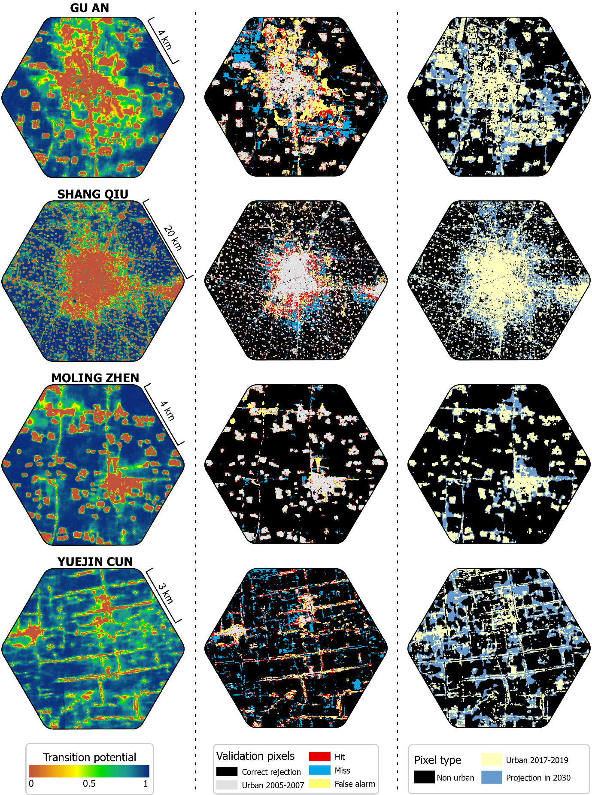

## 3.4 Accuracy

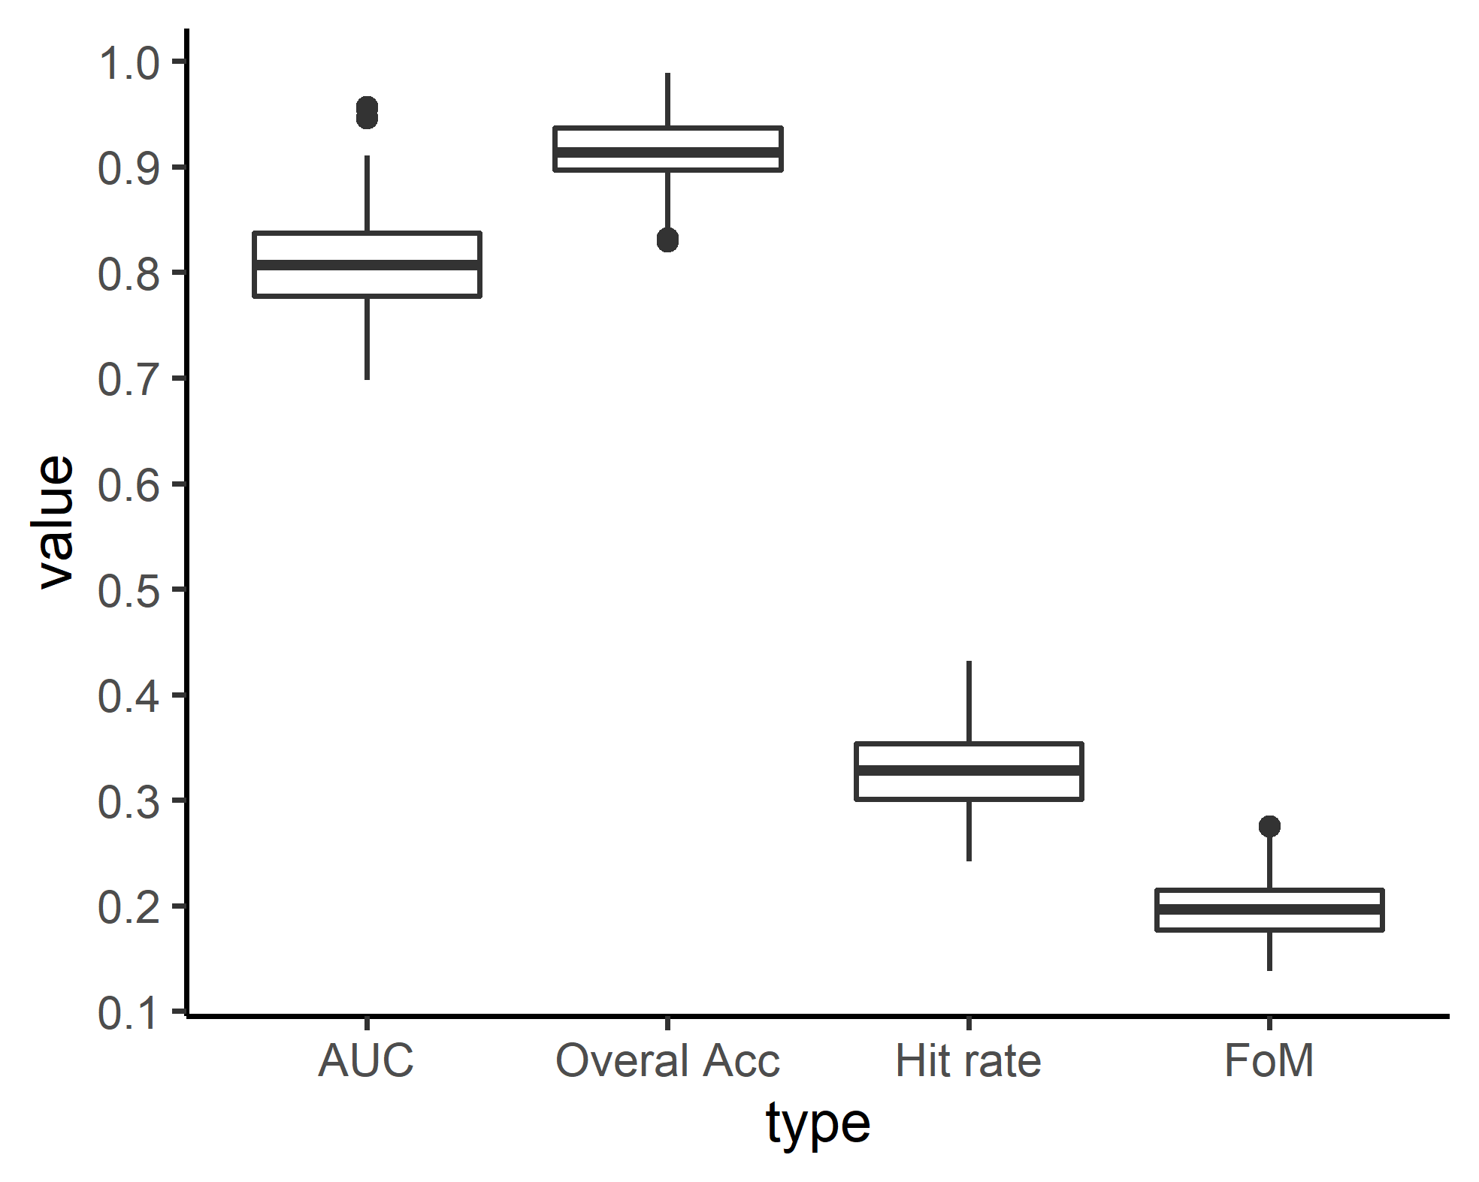

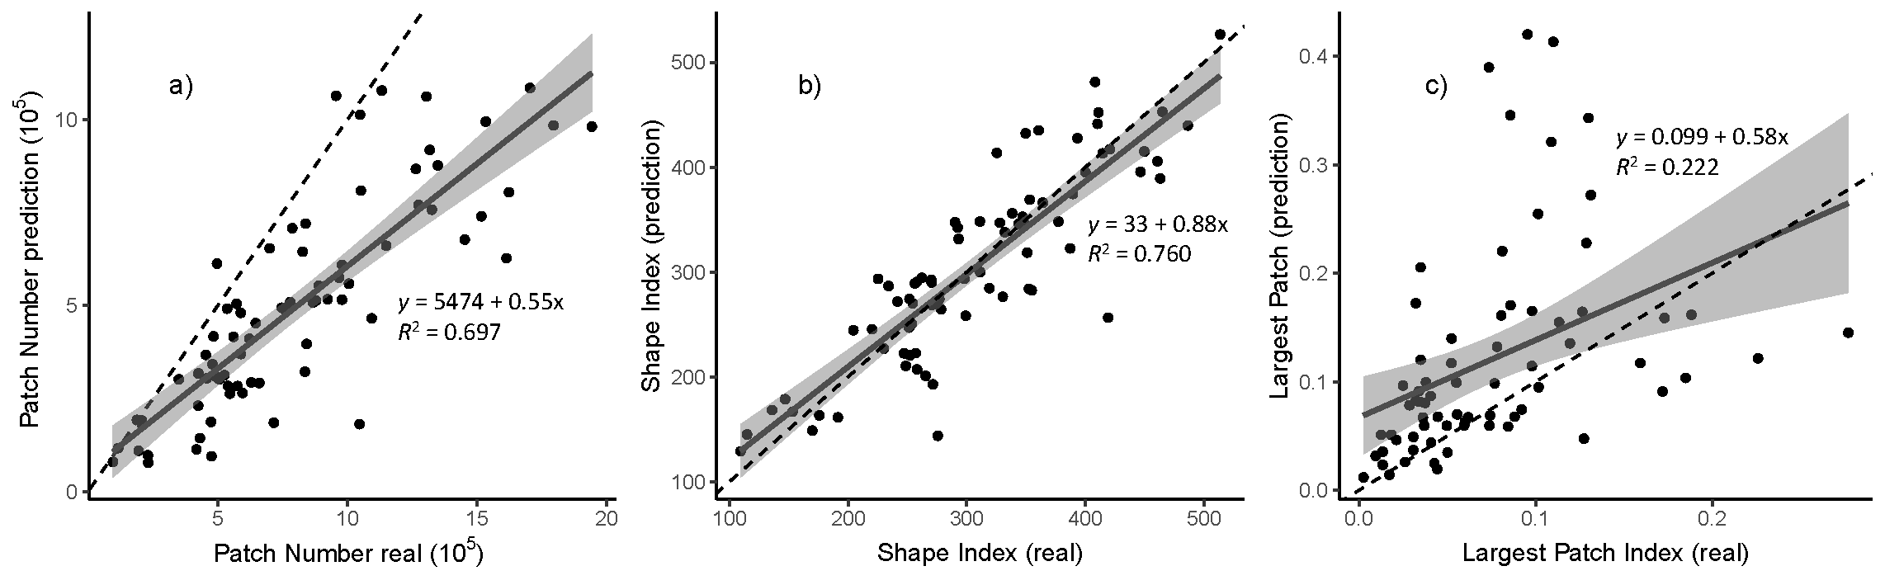

## 3.5 Prediction

